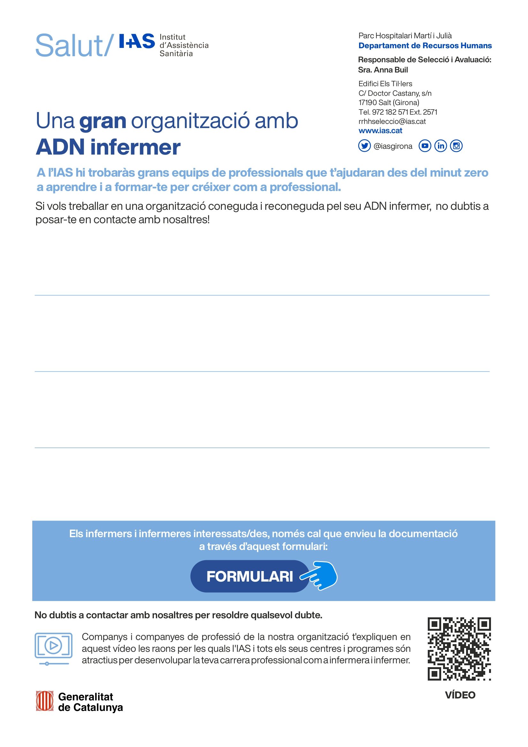
http://www.ias.cat/ca/contacta/727
Es valora:
- Experiència en lloc de treball similar
- Formació relacionada amb ell lloc de treball
- Capacitat pel treball en equip
- Capacitat de tracte / atenció a les persones

Oferta de feina:
S’ ofereix incorporar-se en una institució pública que forma part del sistema sanitari integral d’utilització pública (SISCAT) de la Generalitat de Catalunya, amb una plantilla d’uns 1.900 professionals, la tasca del quals es l’atenció de la salut amb continuïtat en els diferents nivells d’atenció: primària, hospitalari, salut mental, sociosanitari i social.
Requisits:
- Grau o diplomatura en infermeria
S’ofereix:
- S’ ofereix contracte de treball estable de llarga durada
- Torn diürn o nocturn
- Jornada completa

